

**ISIT307 BACKEND WEB PROGRAMMING**

**Assignment 2**

My name: Leviandran, Dominic Loh

My SIM student number: 7222348, 10227916

My email address: [leviandr001@mymail.sim.edu.sg](mailto:leviandr001@mymail.sim.edu.sg), [djkloh002@mymail.sim.edu.sg](mailto:djkloh002@mymail.sim.edu.sg)

Assignment number: 2

**Table of Contents**

**User manual…………………………………………………………………………………………………**

**Source Code…………………………………………………………………………………………………**

# User Manual

## Homepage

In the HomePage the user will be shown the rules of the challenge and the option to enter their desired name



## Category

The User can select which category of challenge they would like to attempt first from this page as well as display the desired name the user has entered. The category page also has the Exit function button which will take the user out of the challenge.

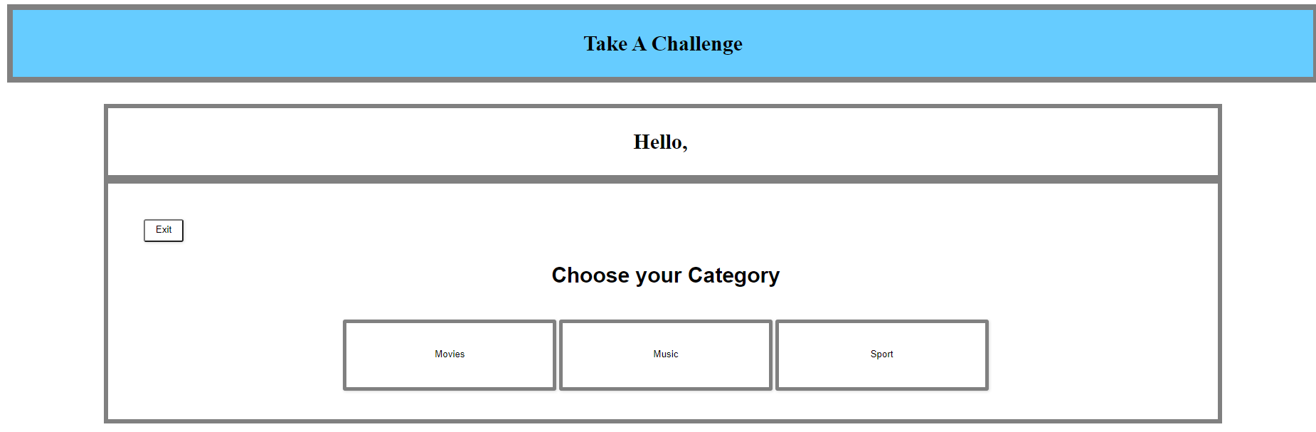

## Movies/Music/Sport Challenge Pages

The User can attempt the challenges in the selected challenge pages based on their selection in the category page. All challenge pages have a Back button function to take the user back to the category page without saving their progression as well as the submit answers and clear fields functions. The 7 questions for each of the challenges are a random set taken from each challenge's individual question pool/bank and the user may refresh to receive a new set of questions

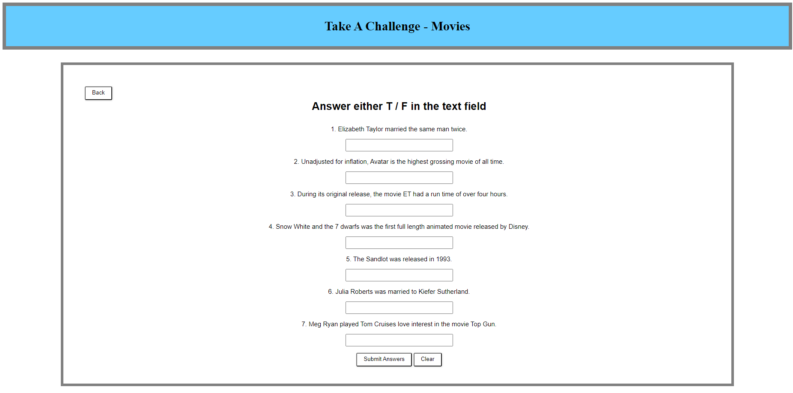

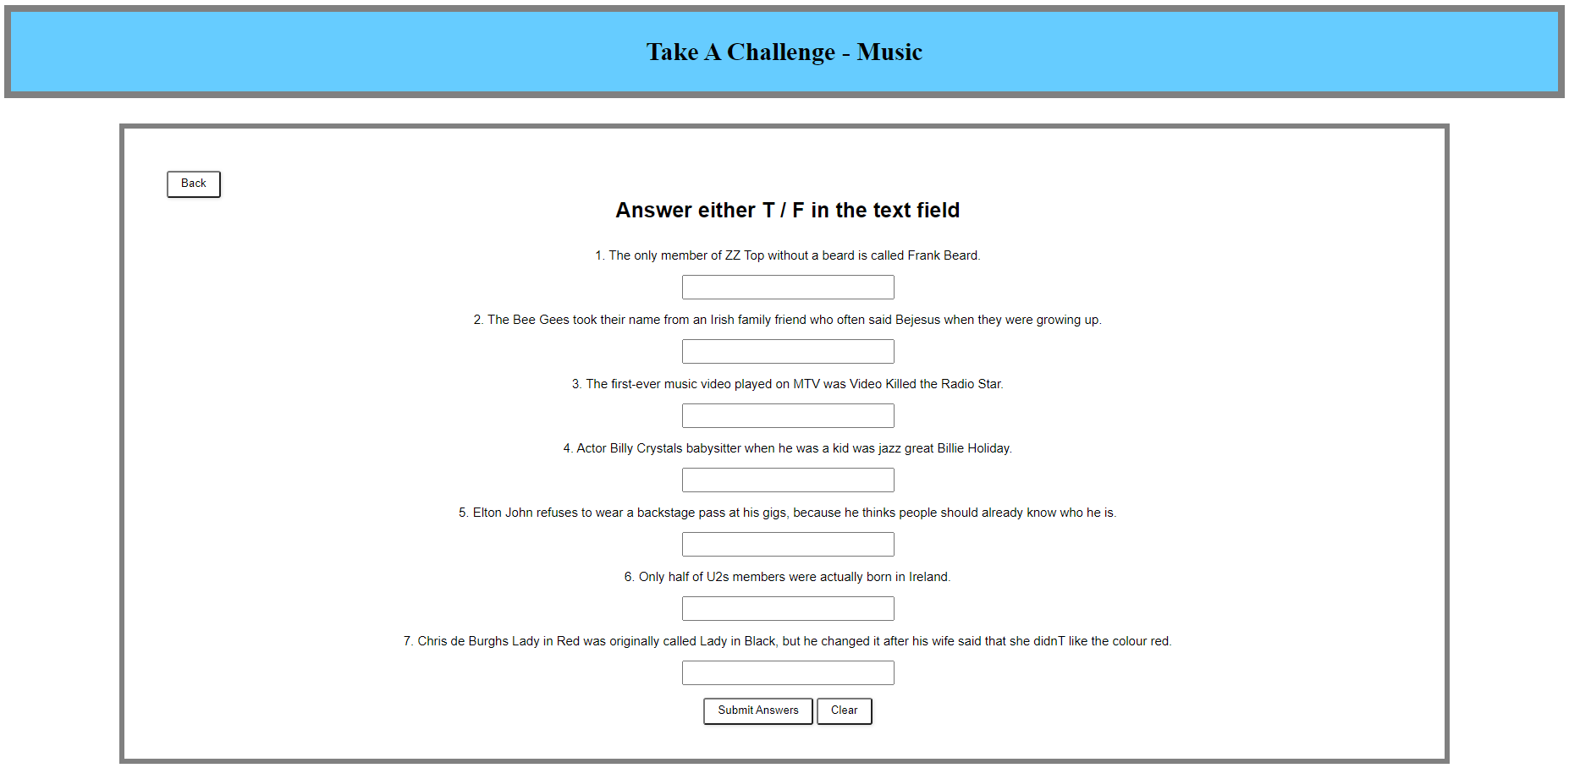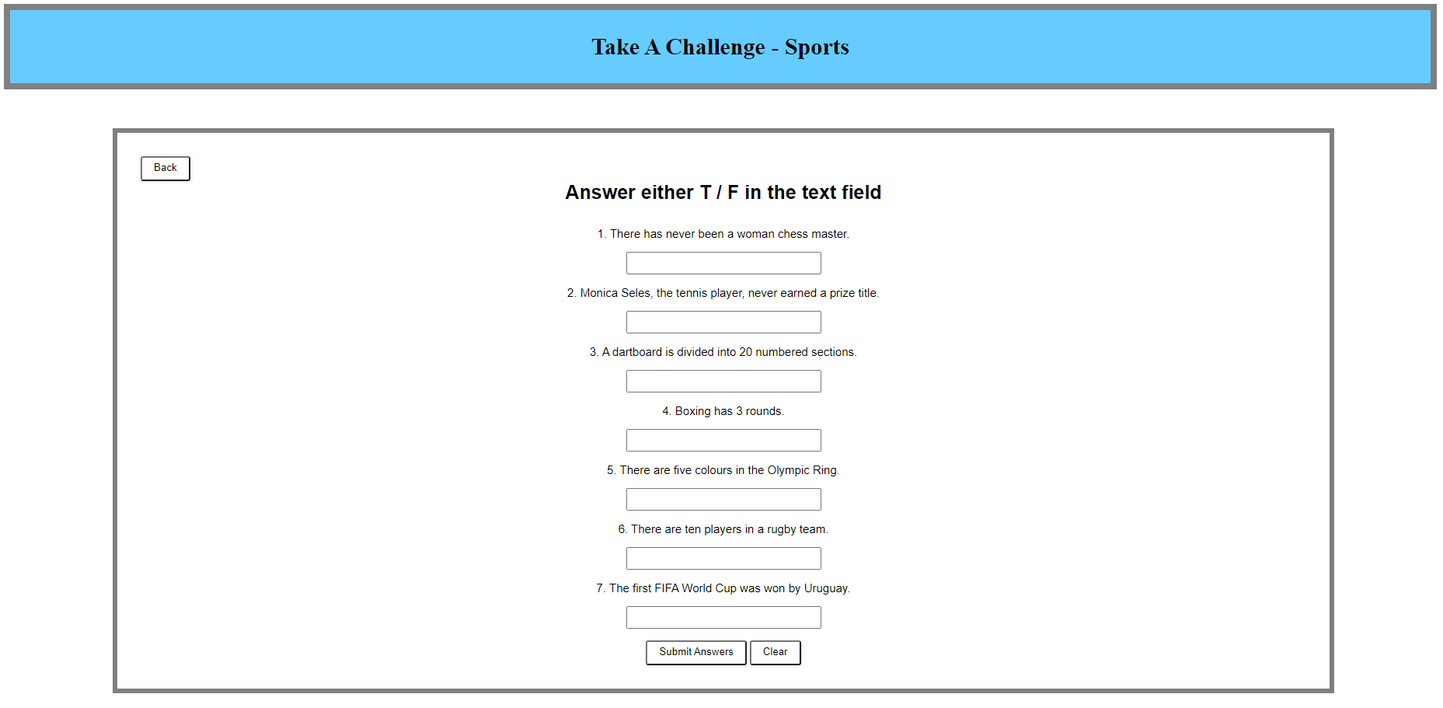

After attempting the challenge the user by entering either T or F in the designated text fields, when the user submits their answers by clicking on the submit button, their scores will be calculated and will receive their results on the same challenge page. The program will only take in answers that have the value of T or F. The program will show if they have either answered a question correctly, a wrong answer and did not attempt an answer. The program will also display their total score based on the calculation for 3 points for each correct answer, -2 points for each wrong answer and 0 points for did not attempt. It will then display buttons as well to select another quiz and to re-attempt the quiz.

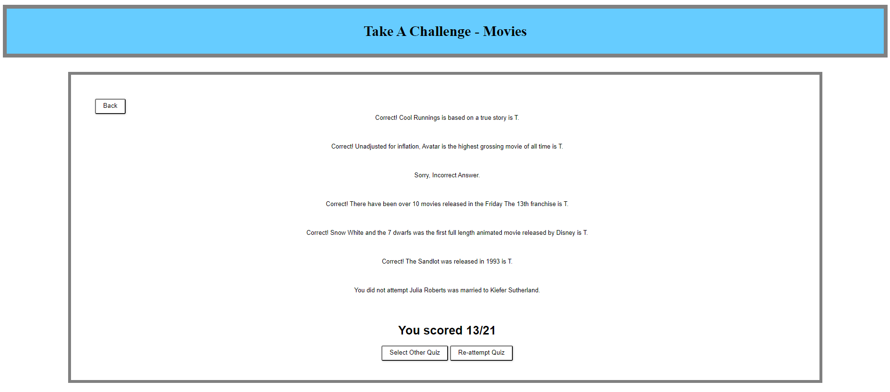

## Exit Page

After clicking on the Exit button on the Category page, the challenge will be ended and the user’s scores will be calculated based on each individual challenge score and tallied up to display a total score to the user. As well as a back to main menu page.

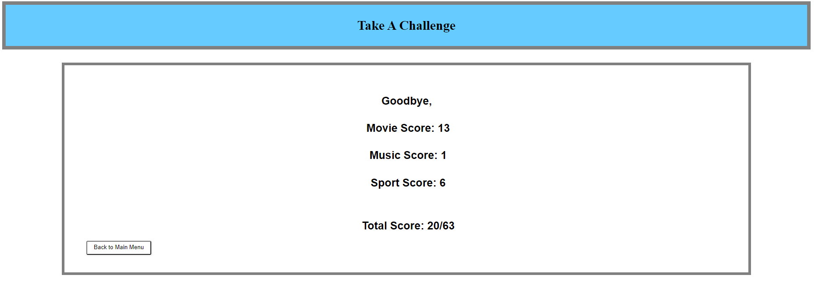

# Source Code

## Importing of entered name

<?php

session_start();

if (isset($_POST["name"])) {

$name = $_POST["name"];

$_SESSION["name"] = $_POST["name"];

echo "<h1 class='block' style='text-align:center; font-size:30px;'>" . "Hello,&nbsp;". $_SESSION["name"] . "</h1>";

}

?>

## Generating question bank and random questions to be displayed as well as calculation of the points

<?php

session_start();

$MovieQuestions = array(

"The nickname of Morgan Freemans character in Million Dollar Baby is Red" => "F",

"Elizabeth Taylor married the same man twice" => "T",

"Gone With The Wind was the first movie to win the Oscar for best picture" => "F",

"Lala land was filmed entirely in Vancouver" => "F",

"Cool Runnings is based on a true story" => "T",

"Unadjusted for inflation, Avatar is the highest grossing movie of all time" => "T",

"The Lion featured in MGM production logo is the same Lion that appears in the Wizard Of Oz" => "F",

"Sophies Choice was Meryl Streeps first ever movie role" => "F",

"Superman made his first movie appearance in the 1940s" => "T",

"During its original release, the movie ET had a run time of over four hours" => "F",

"Mary Poppins features the first use of a swear word in a Hollywood movie" => "F",

"Tom Hanks speaks less than 200 words in Toy Story 2" => "F",

"There have been over 10 movies released in the Friday The 13th franchise" => "T",

"Snow White and the 7 dwarfs was the first full length animated movie released by Disney" => "T",

"The Sandlot was released in 1993" => "T",

"Moonlight won Best Picture in 2018" => "F",

"Molly Ringwald made four movies with director John Hughes" => "F",

"Julia Roberts was married to Kiefer Sutherland" => "F",

"Val Kilmer was offered the role of Johnny in the movie Dirty Dancing" => "T",

"Meg Ryan played Tom Cruises love interest in the movie Top Gun" => "F"

);

$RandomQuestions = array_rand($MovieQuestions,7);

function calculatepoints($correct,$wrong) {

$total = ($correct * 3)-($wrong * 2);

return $total;

}

$wrong = 0;

$correct = 0;

$counter = 1;

$showpoints = 0;

if (isset($_POST['submit'])) {

$Answers = $_POST['ans'];

if (is_array($Answers)) {

foreach ($Answers as $Questions => $Response) {

$Response = stripslashes($Response);

if (strlen($Response)>0) {

if (strcasecmp($MovieQuestions["$Questions"],$Response)==0) {

echo "<label>Correct! $Questions is " . $MovieQuestions[$Questions] . ".</label><br /><br />\n";

$correct++;

}

else {

echo "<label>Sorry, Incorrect Answer.</label><br /><br />\n";

$wrong++;

}

}

else {

echo "<label>You did not attempt $Questions.</label><br /><br />\n";

}

}

}

$showpoints = calculatepoints($correct,$wrong);

if ($showpoints > 0) {

if (empty($_SESSION["moviescore"])) {

$_SESSION["moviescore"] = $showpoints;

}

elseif ($showpoints > $_SESSION["moviescore"]) {

$_SESSION["moviescore"] = $showpoints;

}

}

echo "<h1 class=naming>You scored $showpoints/21</h1>";

echo "<button onclick=\"window.location.href = 'category.php';\" >Select Other Quiz</button>&nbsp;";

echo "<button onclick=\"window.location.href = 'movies.php';\" >Re-attempt Quiz</button>";

}

else {

if(!empty($_SESSION["moviescore"])){

echo "<label class='naming'>Highest attempt: ";

echo $_SESSION["moviescore"];

echo "/21</label>";

}

echo "<label class='naming'>Answer either T / F in the text field </label><br/>";

echo "<form action='movies.php' method='POST' autocomplete='off'>\n";

for ($i=0; $i < 7 ; $i++) {

echo "<label class='question-text'>$counter. ";

echo "$RandomQuestions[$i].</label>";

echo "<input type='text' class='input-field-quiz' name='ans[$RandomQuestions[$i]]' /><br /><br />";

$counter++;

}

echo "<input type='submit' name='submit' value='Submit Answers' /> ";

echo "<input type='reset' name='reset' value='Clear' />\n";

echo "</form>\n";

}

?>

## End of session screen and calculation of total score

<?php

session_start();

if(isset($_SESSION["name"])) {

echo "<h1 class='naming'>" . "Goodbye,&nbsp;" . $_SESSION["name"] . "</h1>";

if (!empty($_SESSION["moviescore"])) {

echo "<h4 class='naming'>Movie Score: " . $_SESSION["moviescore"] . "</h4>";

}

else {

$_SESSION["moviescore"] = 0;

echo "<h4 class='naming'>Movie Score: " . $_SESSION["moviescore"] . "</h4>";

}

if (!empty($_SESSION["musicscore"])) {

echo "<h4 class='naming'>Music Score: " . $_SESSION["musicscore"] . "</h4>";

}

else {

$_SESSION["musicscore"] = 0;

echo "<h4 class='naming'>Music Score: " . $_SESSION["musicscore"] . "</h4>";

}

if (!empty($_SESSION["sportscore"])) {

echo "<h4 class='naming'>Sport Score: " . $_SESSION["sportscore"] . "</h4>";

}

else {

$_SESSION["sportscore"] = 0;

echo "<h4 class='naming'>Sport Score: " . $_SESSION["sportscore"] . "</h4>";

}

if ($_SESSION["sportscore"] >= 0 && $_SESSION["sportscore"] >= 0 && $_SESSION["sportscore"] >= 0) {

$totalscore = $_SESSION["moviescore"] + $_SESSION["musicscore"] + $_SESSION["sportscore"];

echo "<br>";

echo "<h2 class='naming'>Total Score: " . $totalscore . "/63</h2>";

}

}

session_destroy();

?>